Easter Vigil

CHRIST LUTHERAN CHURCH | Lodi, California
March 30, 2024

WELCOME TO WORSHIP
Welcome to Christ Lutheran Church. We pray that your soul will be strengthened by the good news about God’s grace, love, and forgiveness given to us. If you would like to learn more about our church, please speak with our pastor or one of our members after the service.
- Bathrooms are located in the fellowship hall. A changing table is located in the women’s bathroom.
WORSHIP THEME
The Church waits for the Lord’s resurrection. Through the dark night of Jesus’ rest in the tomb, we hold our breath for the coming dawn. But we wait in the sure confidence that the dawn is coming: Christ will rise.

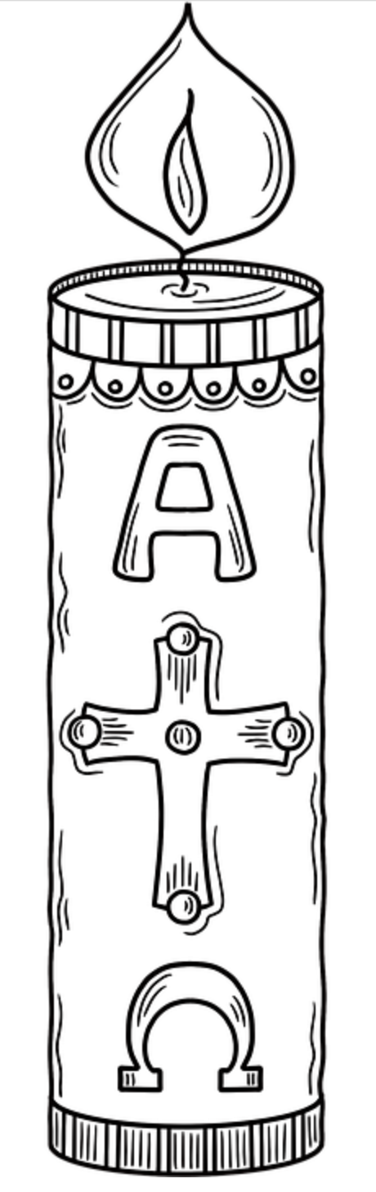
The Service of Light
The congregation gathers outside the nave of the church around a naturally kindled fire. We are reminded that Christ is the Light of the World, the Light no darkness can overcome. We follow his light, represented by the Paschal Candle, into the sanctuary, where we are reminded of the story of man’s sin and God’s deliverance and prepare to greet the Day of Salvation: Easter Sunday.
M: In the name of the Father, and of the Son ✙, and of the Holy Spirit
C: Amen.
M: On this most holy night, in which our Lord Jesus Christ passed over from death to life, we are gathered here in vigil and prayer. This is the commemoration of our Lord’s resurrection in which, by hearing his Word and celebrating his sacraments, we share in his victory over death.
Let us pray.

O God, you are like a refiner’s fire, and your Spirit kindles the hearts of your faithful people with the fire of your love. Bless us as we celebrate this Easter festival that, burning with desire for life with you, we may be found rightly prepared to share in the feast of light which has no end, through Jesus Christ, your Son, our Lord, who lives and reigns with you and the Holy Spirit, one God, now and forever.
C: Amen.
The minister traces the cross and the Greek letters Α and Ω, saying:
M: Christ Jesus, the same yesterday, today, and forever, the beginning and the end, the Alpha and the Omega.
The minister traces the year on the candle.
M: His are time and eternity; his are the glory and dominion now and forever.
The minister places 5 nails upon the candle, representing the wounds of Christ.
M: By his wounds we are healed now and forever.
The Paschal candle is lit from the newly kindled fire.
M: May the light of Christ, who is risen in glory from the dead, scatter all the darkness of our hearts and minds.
Let us pray.
Almighty and most merciful Father, once we were darkness, but now we are light in Jesus Christ our Lord. Abundantly bless all who joyfully celebrate this night in faith in the resurrection of our Lord Jesus Christ. Fill us with your heavenly blessing in him, who lives and reigns with you and the Holy Spirit, one God, now and forever.
C: Amen.
All light their own candles by the flame of the paschal candle.
M: The light of Christ.
C: Thanks be to God.
The congregation processes into the sanctuary following the Paschal candle. The women lead the procession to remember that the first witnesses to the Resurrection were the women who came to finish preparing his body for burial.
Halfway to the altar, the minister pauses.
M: The light of Christ.
C: Thanks be to God.

After arriving at the altar, the minister faces the congregation, holding the Paschal candle aloft.
M: The light of Christ.
C: Thanks be to God.
M: Rejoice now, all you heavenly choirs of angels; rejoice now, all creation; sound forth, trumpet of salvation, and proclaim the triumph of our King.
Rejoice, too, all the earth, in the radiance of the light now poured upon you and made brilliant by the brightness of the everlasting King; know that the ancient darkness has been forever banished.
Rejoice, O Church of Christ, clothed in the brightness of this light; let all this house of God ring out with rejoicing, with the praises of all God’s faithful people.
The Lord be with you.
C: And also with you.
M: Lift up your hearts.
C: We lift them up to the Lord.
M: Let us give thanks to the Lord our God.
C: It is right to give him thanks and praise.
M: It is truly good and right that we should at all times and in all places, with all our hearts and minds and voices, praise you, O Lord, Holy Father, almighty and everlasting God, and your one and only Son, Jesus Christ. For he is the true Paschal Lamb, who offered himself for the sin of the world, who has cleansed us by the shedding of his precious blood.
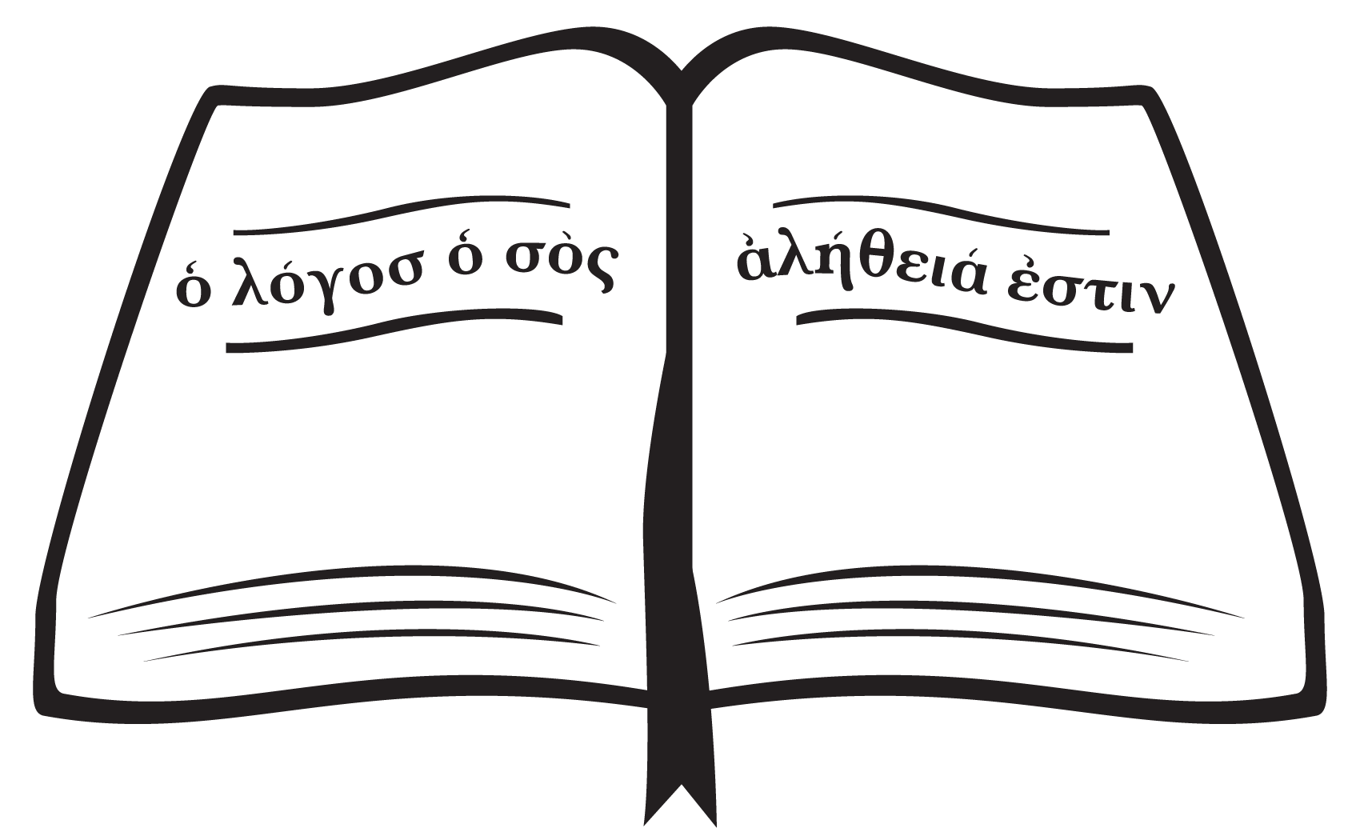
This is the night when you brought our ancestors, the children of Israel, out of bondage in Egypt and led them through the Red Sea on dry ground. This is the night when all who believe in Christ are delivered from bondage to sin and are restored to life and immortality. This is the night when Christ, the Life, arose from the dead. The seal of the tomb is broken and the morning of the new creation breaks forth out of night. Oh, how wonderful and boundless is your mercy toward us, O God, that to redeem a slave you gave your Son.
How holy is this night when all wickedness is put to flight and sin is washed away. How holy is this night when innocence is restored to the fallen and joy is given to the downcast. How blessed is this night when mankind is reconciled to God in Christ.
Holy Father, accept now the evening sacrifices of our thanksgiving and praise. Let Christ, the true Light and Morning Star, shine in our hearts, he who gives light to all creation, who lives and reigns with you and the Holy Spirit, one God, now and forever.
C: Amen.
The congregation’s candles are extinguished.
The Service of Readings
During the all-night vigils of the early church, large portions of Scripture were read to remind the congregation of God’s history of salvation and deliverance for his people, as well as our hope for resurrection and eternal life.
M: On this most holy night, our Savior Christ the Lord broke the power of death and by his resurrection brought life and salvation to all creation. Let us praise the Lord, for he truly keeps his word. The sun of righteousness has dawned on those sitting in darkness and in the shadow of death.
CREATION Genesis 1:1–2:3
M: In the beginning God created the heavens and the earth. Now the earth was formless and empty, darkness was over the surface of the deep, and the Spirit of God was hovering over the waters.
And God said, “Let there be light,” and there was light. God saw that the light was good, and he separated the light from the darkness. God called the light “day,” and the darkness he called “night.” And there was evening, and there was morning—the first day.
And God said, “Let there be a vault between the waters to separate water from water.” So God made the vault and separated the water under the vault from the water above it. And it was so. God called the vault “sky.” And there was evening, and there was morning—the second day.
And God said, “Let the water under the sky be gathered to one place, and let dry ground appear.” And it was so. God called the dry ground “land,” and the gathered waters he called “seas.” And God saw that it was good.
Then God said, “Let the land produce vegetation: seed-bearing plants and trees on the land that bear fruit with seed in it, according to their various kinds.” And it was so. The land produced vegetation: plants bearing seed according to their kinds and trees bearing fruit with seed in it according to their kinds. And God saw that it was good. And there was evening, and there was morning—the third day.
And God said, “Let there be lights in the vault of the sky to separate the day from the night, and let them serve as signs to mark sacred times, and days and years, and let them be lights in the vault of the sky to give light on the earth.” And it was so. God made two great lights—the greater light to govern the day and the lesser light to govern the night. He also made the stars. God set them in the vault of the sky to give light on the earth, to govern the day and the night, and to separate light from darkness. And God saw that it was good. And there was evening, and there was morning—the fourth day.
And God said, “Let the water teem with living creatures, and let birds fly above the earth across the vault of the sky.” So God created the great creatures of the sea and every living thing with which the water teems and that moves about in it, according to their kinds, and every winged bird according to its kind. And God saw that it was good. God blessed them and said, “Be fruitful and increase in number and fill the water in the seas, and let the birds increase on the earth.” And there was evening, and there was morning—the fifth day.
And God said, “Let the land produce living creatures according to their kinds: the livestock, the creatures that move along the ground, and the wild animals, each according to its kind.” And it was so. God made the wild animals according to their kinds, the livestock according to their kinds, and all the creatures that move along the ground according to their kinds. And God saw that it was good.
Then God said, “Let us make mankind in our image, in our likeness, so that they may rule over the fish in the sea and the birds in the sky, over the livestock and all the wild animals, and over all the creatures that move along the ground.”
So God created mankind in his own image,
in the image of God he created them;
male and female he created them.
God blessed them and said to them, “Be fruitful and increase in number; fill the earth and subdue it. Rule over the fish in the sea and the birds in the sky and over every living creature that moves on the ground.”
Then God said, “I give you every seed-bearing plant on the face of the whole earth and every tree that has fruit with seed in it. They will be yours for food. And to all the beasts of the earth and all the birds in the sky and all the creatures that move along the ground—everything that has the breath of life in it—I give every green plant for food.” And it was so.
God saw all that he had made, and it was very good. And there was evening, and there was morning—the sixth day.
Thus the heavens and the earth were completed in all their vast array.
By the seventh day God had finished the work he had been doing; so on the seventh day he rested from all his work. Then God blessed the seventh day and made it holy, because on it he rested from all the work of creating that he had done.
M: The Word of the Lord
C: Thanks be to God.
HYMN Jesus Christ, My Sure Defense| CW 167, v. 1
THE FLOOD Genesis 7:1–5, 11–18; 8:6–18; 9:8–13
M: The Lord then said to Noah, “Go into the ark, you and your whole family, because I have found you righteous in this generation. Take with you seven pairs of every kind of clean animal, a male and its mate, and one pair of every kind of unclean animal, a male and its mate, and also seven pairs of every kind of bird, male and female, to keep their various kinds alive throughout the earth. Seven days from now I will send rain on the earth for forty days and forty nights, and I will wipe from the face of the earth every living creature I have made.”
And Noah did all that the Lord commanded him.
In the six hundredth year of Noah’s life, on the seventeenth day of the second month—on that day all the springs of the great deep burst forth, and the floodgates of the heavens were opened. And rain fell on the earth forty days and forty nights.
On that very day Noah and his sons, Shem, Ham and Japheth, together with his wife and the wives of his three sons, entered the ark. They had with them every wild animal according to its kind, all livestock according to their kinds, every creature that moves along the ground according to its kind and every bird according to its kind, everything with wings. Pairs of all creatures that have the breath of life in them came to Noah and entered the ark. The animals going in were male and female of every living thing, as God had commanded Noah. Then the Lord shut him in.
For forty days the flood kept coming on the earth, and as the waters increased they lifted the ark high above the earth. The waters rose and increased greatly on the earth, and the ark floated on the surface of the water.
After forty days Noah opened a window he had made in the ark and sent out a raven, and it kept flying back and forth until the water had dried up from the earth. Then he sent out a dove to see if the water had receded from the surface of the ground. But the dove could find nowhere to perch because there was water over all the surface of the earth; so it returned to Noah in the ark. He reached out his hand and took the dove and brought it back to himself in the ark. He waited seven more days and again sent out the dove from the ark. When the dove returned to him in the evening, there in its beak was a freshly plucked olive leaf! Then Noah knew that the water had receded from the earth. He waited seven more days and sent the dove out again, but this time it did not return to him.
By the first day of the first month of Noah’s six hundred and first year, the water had dried up from the earth. Noah then removed the covering from the ark and saw that the surface of the ground was dry. By the twenty-seventh day of the second month the earth was completely dry.
Then God said to Noah, “Come out of the ark, you and your wife and your sons and their wives. Bring out every kind of living creature that is with you—the birds, the animals, and all the creatures that move along the ground—so they can multiply on the earth and be fruitful and increase in number on it.”
So Noah came out, together with his sons and his wife and his sons’ wives.
Then God said to Noah and to his sons with him: “I now establish my covenant with you and with your descendants after you and with every living creature that was with you—the birds, the livestock and all the wild animals, all those that came out of the ark with you—every living creature on earth. I establish my covenant with you: Never again will all life be destroyed by the waters of a flood; never again will there be a flood to destroy the earth.”
And God said, “This is the sign of the covenant I am making between me and you and every living creature with you, a covenant for all generations to come: I have set my rainbow in the clouds, and it will be the sign of the covenant between me and the earth.
M: The Word of the Lord
C: Thanks be to God.
HYMN Jesus Christ, My Sure Defense| CW 167, v. 2
ISRAEL DELIVERED AT THE RED SEA Exodus 14:10–15:1
M: As Pharaoh approached, the Israelites looked up, and there were the Egyptians, marching after them. They were terrified and cried out to the Lord. They said to Moses, “Was it because there were no graves in Egypt that you brought us to the desert to die? What have you done to us by bringing us out of Egypt? Didn’t we say to you in Egypt, ‘Leave us alone; let us serve the Egyptians’? It would have been better for us to serve the Egyptians than to die in the desert!”
Moses answered the people, “Do not be afraid. Stand firm and you will see the deliverance the Lord will bring you today. The Egyptians you see today you will never see again. The Lord will fight for you; you need only to be still.”
Then the Lord said to Moses, “Why are you crying out to me? Tell the Israelites to move on. Raise your staff and stretch out your hand over the sea to divide the water so that the Israelites can go through the sea on dry ground. I will harden the hearts of the Egyptians so that they will go in after them. And I will gain glory through Pharaoh and all his army, through his chariots and his horsemen. The Egyptians will know that I am the Lord when I gain glory through Pharaoh, his chariots and his horsemen.”
Then the angel of God, who had been traveling in front of Israel’s army, withdrew and went behind them. The pillar of cloud also moved from in front and stood behind them, coming between the armies of Egypt and Israel. Throughout the night the cloud brought darkness to the one side and light to the other side; so neither went near the other all night long.
Then Moses stretched out his hand over the sea, and all that night the Lord drove the sea back with a strong east wind and turned it into dry land. The waters were divided, and the Israelites went through the sea on dry ground, with a wall of water on their right and on their left.
The Egyptians pursued them, and all Pharaoh’s horses and chariots and horsemen followed them into the sea. During the last watch of the night the Lord looked down from the pillar of fire and cloud at the Egyptian army and threw it into confusion. He jammed the wheels of their chariots so that they had difficulty driving. And the Egyptians said, “Let’s get away from the Israelites! The Lord is fighting for them against Egypt.”
Then the Lord said to Moses, “Stretch out your hand over the sea so that the waters may flow back over the Egyptians and their chariots and horsemen.” Moses stretched out his hand over the sea, and at daybreak the sea went back to its place. The Egyptians were fleeing toward it, and the Lord swept them into the sea. The water flowed back and covered the chariots and horsemen—the entire army of Pharaoh that had followed the Israelites into the sea. Not one of them survived.
But the Israelites went through the sea on dry ground, with a wall of water on their right and on their left. That day the Lord saved Israel from the hands of the Egyptians, and Israel saw the Egyptians lying dead on the shore. And when the Israelites saw the mighty hand of the Lord displayed against the Egyptians, the people feared the Lord and put their trust in him and in Moses his servant.
Then Moses and the Israelites sang this song to the Lord:
“I will sing to the Lord,
for he is highly exalted.
Both horse and driver
he has hurled into the sea.
M: The Word of the Lord
C: Thanks be to God.
HYMN Jesus Christ, My Sure Defense| CW 167, v. 3
THE FIERY FURNACE Daniel 3:1–29
M: King Nebuchadnezzar made an image of gold, sixty cubits high and six cubits wide, and set it up on the plain of Dura in the province of Babylon. He then summoned the satraps, prefects, governors, advisers, treasurers, judges, magistrates and all the other provincial officials to come to the dedication of the image he had set up. So the satraps, prefects, governors, advisers, treasurers, judges, magistrates and all the other provincial officials assembled for the dedication of the image that King Nebuchadnezzar had set up, and they stood before it.
Then the herald loudly proclaimed, “Nations and peoples of every language, this is what you are commanded to do: As soon as you hear the sound of the horn, flute, zither, lyre, harp, pipe and all kinds of music, you must fall down and worship the image of gold that King Nebuchadnezzar has set up. Whoever does not fall down and worship will immediately be thrown into a blazing furnace.”
Therefore, as soon as they heard the sound of the horn, flute, zither, lyre, harp and all kinds of music, all the nations and peoples of every language fell down and worshiped the image of gold that King Nebuchadnezzar had set up.
At this time some astrologers came forward and denounced the Jews. They said to King Nebuchadnezzar, “May the king live forever! Your Majesty has issued a decree that everyone who hears the sound of the horn, flute, zither, lyre, harp, pipe and all kinds of music must fall down and worship the image of gold, and that whoever does not fall down and worship will be thrown into a blazing furnace. But there are some Jews whom you have set over the affairs of the province of Babylon—Shadrach, Meshach and Abednego—who pay no attention to you, Your Majesty. They neither serve your gods nor worship the image of gold you have set up.”
Furious with rage, Nebuchadnezzar summoned Shadrach, Meshach and Abednego. So these men were brought before the king, and Nebuchadnezzar said to them, “Is it true, Shadrach, Meshach and Abednego, that you do not serve my gods or worship the image of gold I have set up? Now when you hear the sound of the horn, flute, zither, lyre, harp, pipe and all kinds of music, if you are ready to fall down and worship the image I made, very good. But if you do not worship it, you will be thrown immediately into a blazing furnace. Then what god will be able to rescue you from my hand?”
Shadrach, Meshach and Abednego replied to him, “King Nebuchadnezzar, we do not need to defend ourselves before you in this matter. If we are thrown into the blazing furnace, the God we serve is able to deliver us from it, and he will deliver us from Your Majesty’s hand. But even if he does not, we want you to know, Your Majesty, that we will not serve your gods or worship the image of gold you have set up.”
Then Nebuchadnezzar was furious with Shadrach, Meshach and Abednego, and his attitude toward them changed. He ordered the furnace heated seven times hotter than usual and commanded some of the strongest soldiers in his army to tie up Shadrach, Meshach and Abednego and throw them into the blazing furnace. So these men, wearing their robes, trousers, turbans and other clothes, were bound and thrown into the blazing furnace. The king’s command was so urgent and the furnace so hot that the flames of the fire killed the soldiers who took up Shadrach, Meshach and Abednego, and these three men, firmly tied, fell into the blazing furnace.
Then King Nebuchadnezzar leaped to his feet in amazement and asked his advisers, “Weren’t there three men that we tied up and threw into the fire?”
They replied, “Certainly, Your Majesty.”
He said, “Look! I see four men walking around in the fire, unbound and unharmed, and the fourth looks like a son of the gods.”
Nebuchadnezzar then approached the opening of the blazing furnace and shouted, “Shadrach, Meshach and Abednego, servants of the Most High God, come out! Come here!”
So Shadrach, Meshach and Abednego came out of the fire, and the satraps, prefects, governors and royal advisers crowded around them. They saw that the fire had not harmed their bodies, nor was a hair of their heads singed; their robes were not scorched, and there was no smell of fire on them.
Then Nebuchadnezzar said, “Praise be to the God of Shadrach, Meshach and Abednego, who has sent his angel and rescued his servants! They trusted in him and defied the king’s command and were willing to give up their lives rather than serve or worship any god except their own God. Therefore I decree that the people of any nation or language who say anything against the God of Shadrach, Meshach and Abednego be cut into pieces and their houses be turned into piles of rubble, for no other god can save in this way.”
M: The Word of the Lord
C: Thanks be to God.
HYMN Jesus Christ, My Sure Defense| CW 167, v. 4,5
A Remembrance of Baptism
During the early days of the church, new converts were often baptized during the Easter Vigil and then had the privilege to join the congregation at the Lord’s table during the Easter festivities. Given the readings with connection to baptism—particularly the Flood and the Crossing of the Red Sea—as well as the historic practice, it is valuable for us to remember our own baptisms.
M: On this most holy night, the whole Church of our Lord Jesus Christ recalls his death and burial, rejoicing in the gospel of his glorious resurrection from the dead. Holy Baptism is the priceless means of grace by which our Father in heaven connects us with Christ in his life, death, and resurrection. The apostle Paul wrote: “All of us who were baptized into Christ Jesus were baptized into his death. We were therefore buried with him through baptism into death in order that, just as Christ was raised from the dead through the glory of the Father, we too may live a new life.” Again Paul wrote: “All of you who were baptized into Christ have clothed yourselves with Christ.”
In Holy Baptism, God takes away our sins and gives new life in Christ our Lord. We solemnly renounce the devil and all his works and all his ways; we confess the gift of faith in God the Father, Son, and Holy Spirit. I ask you: do you reject the devil along with all his lies and empty promises?
C: Yes, and I ask God to help me.
M: Do you believe in God, the Father almighty?
C: Yes, I believe in God the Father almighty, maker of heaven and earth.
M: Do you believe in Jesus Christ, his only Son?
C: Yes, I believe in Jesus Christ, his only Son, our Lord
Who was conceived by the Holy Spirit,
born of the virgin Mary,
suffered under Pontius Pilate,
was crucified, died, and was buried.
He descended into hell.
The third day he rose again from the dead.
He ascended into heaven and is seated at the right hand of God the Father almighty.
From there he will come to judge the living and the dead.
M: Do you believe in the Holy Spirit?
C: Yes I believe in the Holy Spirit,
the holy Christian Church,
the communion of saints,
the forgiveness of sins,
the resurrection of the body,
and the life everlasting. Amen.
M: Do you intend to continue in this faith, to be diligent in the use of word and sacrament and in faith and action remain true to God—Father, Son, and Holy Spirit—as long as you live?
C: Yes and I ask God to help me.
M: Almighty God, the Father of our Lord Jesus Christ, who has given you the new birth of water and of the Spirit and has forgiven you all your sins, strengthen you with his grace to life everlasting.
C: Amen.
M: Let us pray.
Merciful Father in heaven, we thank you for the gift of Baptism by which you wash away sin and give us a new and eternal life. Help us each day to remember that through Baptism you clothe us with Christ, that we may stand holy and righteous before you. Look with favor on [name], that he may be kept safe by the gift of your Spirit, grow daily in your grace, and live forever by the power of the risen Christ. Make us willing to carry out our responsibilities to all the baptized so that all may finally come to the blessed joys of heaven; through Jesus Christ our Lord.
C: Amen.
M: Almighty God, the Father of our Lord ✙ Jesus Christ, strengthen you by his Spirit, that Christ, dwelling in your hearts by faith, may fill you with all spiritual blessings. Go in peace.
THE RESURRECTION Mark 16:1–8
M: When the Sabbath was over, Mary Magdalene, Mary the mother of James, and Salome bought spices so that they might go to anoint Jesus’ body. Very early on the first day of the week, just after sunrise, they were on their way to the tomb and they asked each other, “Who will roll the stone away from the entrance of the tomb?”
But when they looked up, they saw that the stone, which was very large, had been rolled away. As they entered the tomb, they saw a young man dressed in a white robe sitting on the right side, and they were alarmed.
“Don’t be alarmed,” he said. “You are looking for Jesus the Nazarene, who was crucified. He has risen! He is not here. See the place where they laid him. But go, tell his disciples and Peter, ‘He is going ahead of you into Galilee. There you will see him, just as he told you.’ ”
Trembling and bewildered, the women went out and fled from the tomb. They said nothing to anyone, because they were afraid.
M: Alleluia! Christ is risen!

The Paschal Greeting

The exchange of “Christ is Risen, he is risen indeed!” is called the Paschal Greeting. It echoes the greeting of the angel to the two Marys at the empty tomb, and expresses our joy to know Jesus has conquered death.

This exchange is also the return of the word Alleluia to our service after the 40 days of Lent. During the early church, this exchange was timed so that the word Alleluia was spoken at midnight.
C: He is risen indeed! Alleluia!
PRAYER OF THE DAY
M: O God, who made this most holy night to shine with the glory of the resurrection of our Lord, preserve in all your people the Spirit of adoption which you have given, that they may serve you in faith and joy, through Jesus Christ, your Son, our Lord,
who lives and reigns with you and the
Holy Spirit, one God, now and forever.
C: Amen.
THE LORD’S PRAYER
Our Father in heaven, hallowed be your name,
your kingdom come, your will be done on earth as in heaven.
Give us today our daily bread.
Forgive us our sins, as we forgive those who sin against us.
Lead us not into temptation, but deliver us from evil.
For the kingdom, the power, and the glory
are yours now and forever. Amen.
BLESSING
M: The almighty and merciful Lord—the Father, the ✙ Son, and the Holy Spirit—bless us and keep us.
C: Amen.
HYMN Morning Breaks Upon the Tomb| CW 159

COPYRIGHT INFORMATION
Content requiring a copyright license is reproduced under OneLicense.net #A-718312. All rights reserved. The Common Service: Texts revised from The Lutheran Hymnal, 1941. Music revised by James Engel. Scripture Quotations: From the Holy Bible, New International Version (NIV 1984), © 1973, 1978, 1984 by Biblica, Inc.

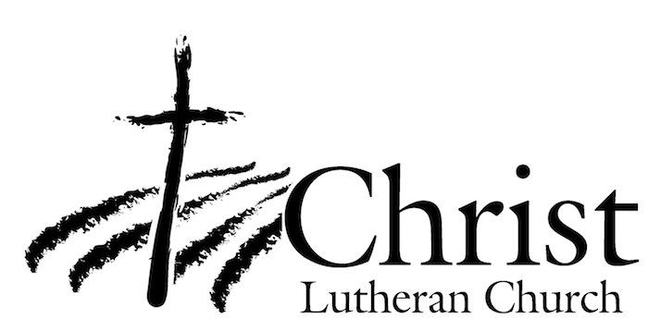
13009 N. Elderberry Ct.
Lodi, CA 95242
www.christlodi.org
209-368-6250
Pastor Timothy Leistekow
WELCOME TO CHRIST EV. LUTHERAN CHURCH!
We preach a message of forgiveness, hope and peace
through the death and resurrection of Jesus Christ.
Families and individuals of all ages will find opportunities
both to grow and to serve.
Our mission statement:
Look what Christ is doing!
He binds us together in fellowship
He gathers us in for worship
He builds us up for service
He sends us out with the gospel

“Now you are the body of Christ,
and each one of you is a part of it.”
(1 Corinthians 12:27)

